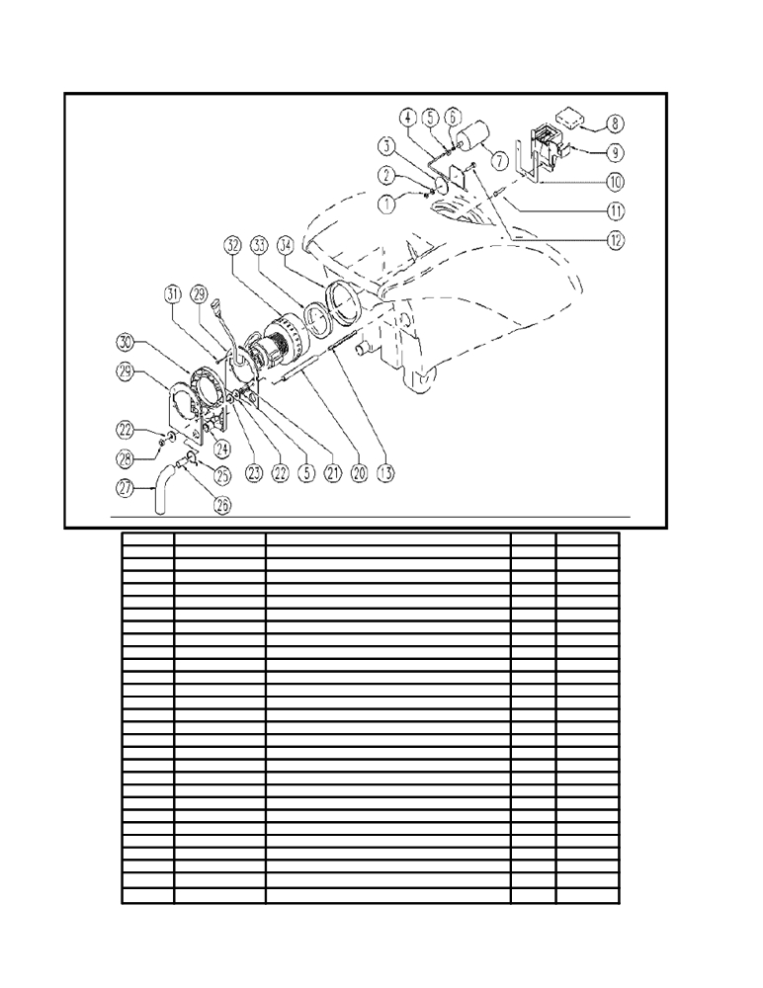

VACUUM GROUP NEW STYLE

ITEM SKU DESCRIPTION QTY FROM
1 E86772 Nut 1 04/2004
2 E86448 AS20 Washer 1 04/2004
3 E86591 Gasket WS20/24-FS28/32 1 04/2004
4 E86592 Rod WS20/24-FS28/32 1 04/2004
5 E86873 Nut 3 04/2004
6 E89213 Insert FS28/32 1 04/2004
7 E86593 Float WS20/24-FS28/32 1 04/2004
8 E86502 Filter 1 04/2004
9 E86595 Support WS20/24-FS28/32 1 04/2004
10 E86365 filter gasket WS20 1 04/2004
11 VTVT00835 SCREW 3 04/2004
12 E86594 Screw WS20/24-FS28/32 1 04/2004
13 E87910 Screw 2 04/2004
20 E88350 Spacer, Vacuum Motor 2 04/2004
21 E86758 Washer 2 04/2004
22 E86719 AS20 Washer 4
23 MPVR35582 RUBBER 2 04/2004
24 E86449 AS20 Bushing for Vac Motor 1 04/2004
25 E86460 Cable tie 12" 1 04/2004
26 TBFX00217 TUBE 1
27 E87940 Sound proofing 1 04/2004
28 E86875 Self-Locking Nut 2 04/2004
29 LAFN51076 FLANGE 2 04/2004
30 ITSO00035 SOUND-PROOFING 1 04/2004
31 VTVT00892 SCREW 4 04/2004
32 E89124 2 stage vac motor WS20/24 after 04B 1
33 E87832 O Ring for Gasket FS28 1 04/2004
34 E86612 Gasket for vacuum motor 1 04/2004

